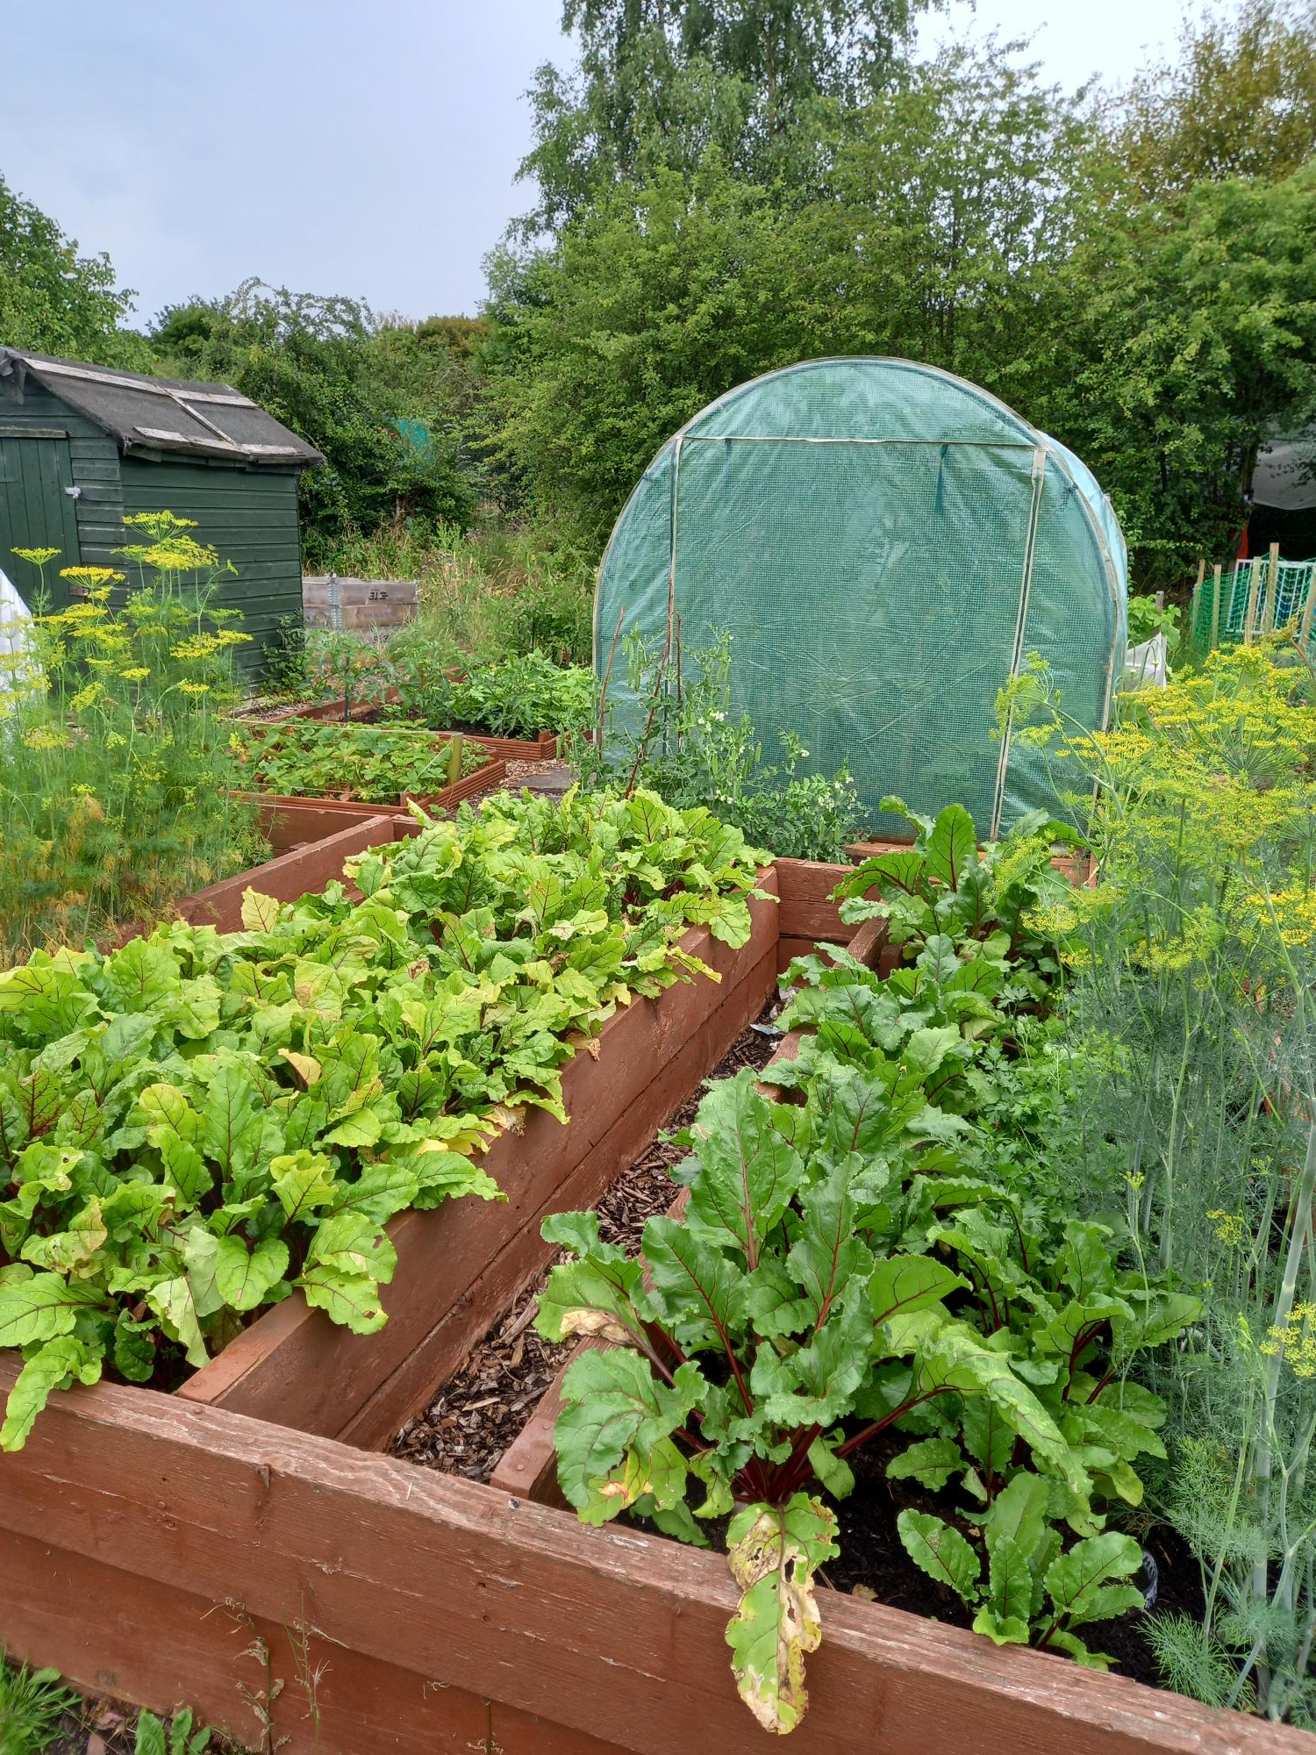  food growers in lanarkshire Exhibition & Competition |   And supported by North Lanarkshire Council

EXHIBITION & COMPETITION
FOR FOOD GROWERS IN LANARKSHIRE
(organised by Forgewood Allotments)

20TH SEPTEMBER 2025

OPEN TO EVERYONE AND ENTRANCE IS FREE

Arrangements:
ADMISSION FOR DISPLAY TABLE £5

Show location:
Forgewood Community Centre
49 Dinmont Cres,
Motherwell ML1 3TT

Event hosted by:
Forgewood Allotment Committee
Arrangements
Doors open to exhibits at 11.30 AM
Exhibits to be staged by 12.10 AM
Judging starts at 12.15 AM
Lifting of exhibits at 2 PM
Sale of flowers at 1.30 PM
Rules:
ALL VEGETABLES MUST BE WASHED AND SIMILAR SIZE.
4 categories to be judged:
- Rooted vegetables
- Top root vegetables
- Flowers
- Children’s section
And Prize for BEST IN SHOW and all above categories
Exhibition display rules:
Vegetables:
Potatoes display 4
Kidney potatoes display 4
Ball turnip display 3 (no swede)
Beetroot long or globe display 3
Parsnip displays 3
Carrots display 3
Heads celery display 2
Leeks long display 2
Shallots display 6
Onions grown from seed display 3
All vegetables must be displayed within the tray (no bigger than 18” x12”). Tray may be dressed but only parsley may be used.
All top root vegetables
Round cabbage display 1
Pointed cabbage display 1
Lettuce display 2
Cauliflower display 2
Cucumbers display 2
Plant parsley display 1 pot – 10 “max size
Beans display 6
Pods of Peas display 6
Tomatoes display 3

Children’s section:
ANIMAL made from vegetables or fruits only.

Flowers section
Cut flowers
Number of blooms must be as scheduled:
CHRYSANTHEMUMS 3 blooms per each vase
DAHLIAS 3 blooms per each vase
GLADIOLI 3 spikes per each vase
ROSES 3 blooms in each vase
BEGONIAS 3 blooms on board
SWEET PEAS 9 spikes in vase

POT PLANTS (any pot size)
- Pendular begonia
- 1 pot plant or flower not in class
- Geranium or pelargonium
- Gloxinia
- Petunia,
- Love lies bleeding,
- Hanging basket of flowers
- Fuchsia
- Liliums
- Hydrangea
- Coleus
- 1pot plant not in class
EXHIBITORS are not allowed to engrave their names on any trophies they have won.
All trophy winners must return trophies to Forgewood Allotment secretary by end of October 2025.
How to sign in for competition:
- Please complete form attached to this brochure (please sign in by the end of August)
- Please pay £5 admission fee (1 table per 1 allotment)
You can pay by cash to Forgewood allotment or
you can use bank transfer:
Forgewood allotments
Sort code: 402247
Account number:12184710
Ref name: Competition
- Forgewood allotment will issue you with a receipt
- Please deliver your items on the day before or by 10 am to Forgewood Community centre.
- Is you have any questions, please contact Michelle or Kat directly on WhatsApp:
Michelle – 07825 885926
Kat – 07882 771841

Judging Arrangements

The judges will judge and verify all displayed items before doors open to the public.
Judges will attach a ticket on the winning exhibits with grade and prize next to the item.
To collect your prize, please bring your winners ticket to Forgewood Committee member representative and collect your well-deserved prize.
GOOD LUCK !!!!
And finally, thank you to everyone for their coming along to support this event and thank you to everyone who helped to make our 1st Forgewood Community Allotment event a big success.

