SEPTEMBER 2025 Newsletter-
Relational mentoringtm scotland

Funded by the Scottish Government until March 2026

Welcome! September 2025

Hello everyone,
Well, it’s been a busy month across Inverclyde, Renfrewshire, Glasgow, North and South Lanarkshire and the Scottish Borders.
During the month we’ve attended Job’s Fairs, locality forums, Job Centres, Food banks, community cafes, schools and nurseries. Not to mention multiple meetings with new partners.
Our social café in our Templeton office has proved very popular with customers enjoying the activities and meeting new people.
Please, as always, reach out if you need any other information and/or would like us to attend any events you have coming ups.

Please use this link to refer and mention the children and their ages in the notes.

Currently we have no waiting lists in every locality, and your customers are being contacted within 24 hours.


Heather Coulthard Ann Nye
Email Heather Email Anne
CUSTOMER FEEDBACK
Hi Becky, they've been amazing, especially from the energy team, he spoke to British Gas on our behalf and managed to get us on the You Pay We Pay scheme so basically we only pay £150 per month for 6 months and British Gas will also pay £150 per month so it'll help us get out of the debt we are in with them and put us into having credit with them"
XXDDDD
“You have taken a massive weight from my shoulders. My stress on my family has been lifted dramatically”

Case studies
Relational mentoring
My customer was under real financial strain due to her daughter’s disability. She was not receiving any support from the school or other agencies and was only receiving Universal Credit. Her and her partner were only eating once a day to make sure the children had enough food. They were unable to go days out or anything due to lack of money.
They didn’t have a cot for the little one as she had grown out of the basket she slept in. Working together they applied for child disability payment, and we found a family fund to apply for days out etc. I also looked around for ways to get much needed cot, beds etc.
This week my customer was accepted for child disability payment which has been backdated. Now she is receiving an extra £550 a month. She was also accepted for the family fund and has been given funding for days out with the family and a voucher for clothing for the children. She also got a cot from a Facebook group I put her in touch with. She told me yesterday that she had done a big shop for the first time in a long time without worrying about everyone eating which is amazing and the extra money will make a massive difference each month.

THIS IS WHAT RELATIONAL MENTORING LOOKS LIKE in collaboration with HEAT
A customer came to us with over £5,000 of energy debt, struggling after losing his job due to a knee operation. He lives with his wife and their two adult autistic sons – the whole family under huge pressure, relying on Universal Credit and worried about how to keep their home warm.
Here’s what we achieved together:
✅ £1,531 written off under back-billing rules.
✅ Switched from an unsuitable day/night rate to a fairer flat-rate tariff, saving the family £250 a year.
✅ Set up an affordable repayment plan (£300/month) to gradually clear debt while keeping usage covered.
✅ Smart meter booked to make sure future bills are accurate and easier to manage.
✅ Shared info on extra support – Warm Home Discount, hardship funds, and tailored tariffs for the future.
👉 This is why our work matters. It’s not just about bills and numbers – it’s about restoring dignity, stability, and hope for families who need it most.

GALLERY
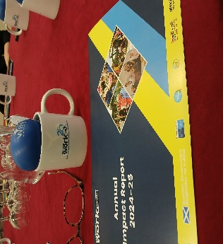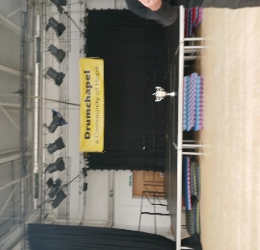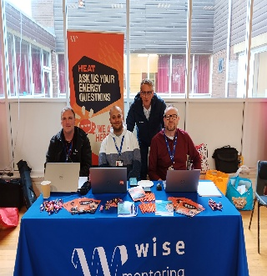
Routes to Work South’s celebration G15’s Thriving Places Working with HEAT at
Of 20 years in South Lanarkshire Blether meeting in Drumchapel Paul’s Parcels North Lanarkshire

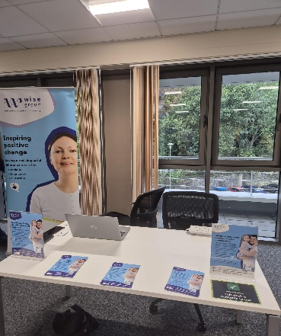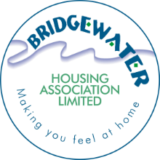

Job’s Fair in the Waterfront Cinema, Greenock New partnership with
Scottish Borders Learning about addiction stigma Bridgewater HA in Renfrewshire

